Measuring energy density of fish and invertebrates
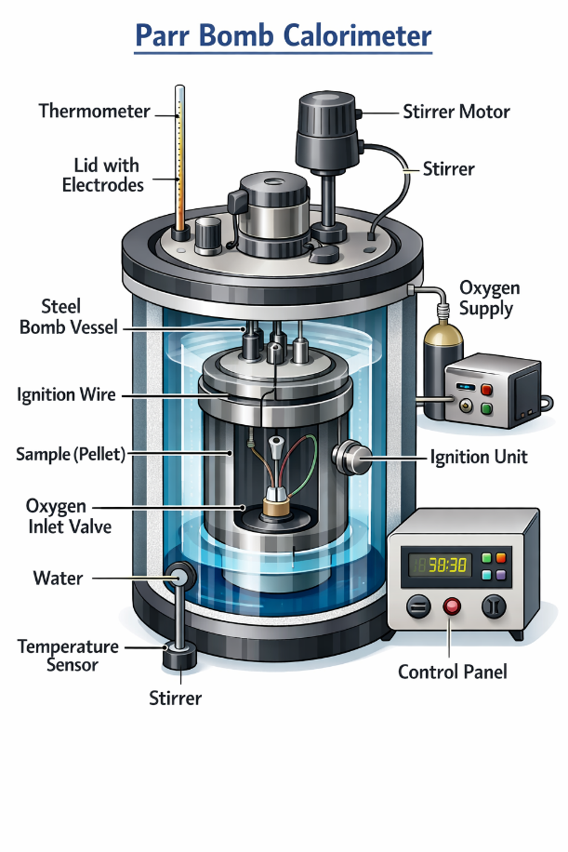
Calorimetry is the science of measuring quantities of heat or energy content in a substance using an instrument known as a calorimeter. Biological samples such as fish or invertebrates are dried and ground, then a weighed subsample is placed in a calorimeter vessel or oxygen bomb. The vessel/bomb is then filled with O₂ and placed in a bucket holding a known quantity of water that is surrounded by an insulated calorimeter jacket (see below). The sample is ignited inside the steel bomb vessel and after combustion, the temperature rise in the surrounding water is proportional to the sample’s energy content that can then be converted to energy density as calories per gram (dry wt). If the dry:wet weight ratio of the sample is known, energy density can also be expressed as calories per gram (wet). A calorie is the heat energy required to raise the water temperature 1°C and is equal to 4.184 Joules. Importantly, 1,000 calories = 1 Calorie, where the former (cal) is generally used to measure energy density of organic matter and the latter (Cal) represents the energy value often found on our food and beverage labels. Information on energy density has been used widely in ecology and fisheries management to understand energy flow in biological systems, describe body condition, used as an input for bioenergetics modeling of fish growth or consumption, and to evaluate contaminant uptake.
Paine, R.T. 1971. The measurement and application of the calorie to ecological problems. Annual Review of Ecology and Systematics 2:145-164.

Energy Unit conversions
- 1 Joule (J) = 0.239 (cal)
- 1 calorie (cal) = 4.184 Joules (J)
Food Energy
- 1 Calorie (Cal) = 1 kilocalorie (kcal) = 1000 calories (cal)
1 Calorie (Cal) = 4,184 Joules (J)

PARR Instrument Company

